שאלה 1:
Given a stack with a limit of k elements, where each k operations that is a copy operation that take O(I) where I is the number of elements in the stack.
Operation running time:
$$push=O\left(1\right)$$
$$pop=O\left(1\right)$$
$$copy_{i}=O\left(i\right)≤O\left(k\right)$$
Here we wrote the running time for each operation.
Let’s use amortize analysis to solve this.
Firstly, we need to understand that the copy running time is bounded by
$$O\left(k\right)$$
Because we are given a stack that can’t exceed k elements.
Copy operations
$$\left\lfloor \left.\frac{m}{k}\right\rfloor \right.$$
Running time analysis
$$E=\frac{\left[\sum_{i=0}^{i=\left\lfloor \left.\frac{m}{k}\right\rfloor \right.}{O\left(k\right)}+\sum_{i=0}^{i=m}{O\left(1\right)}\right]}{m}≤\frac{\left[\sum_{i=0}^{i=\frac{m}{k}}{O\left(k\right)}+\sum_{i=0}^{i=m}{O\left(1\right)}\right]}{m}$$
$$\frac{\left[\sum_{i=0}^{i=\frac{m}{k}}{O\left(k\right)}+\sum_{i=0}^{i=m}{O\left(1\right)}\right]}{m}=\frac{\left[\frac{m}{k}⋅O\left(k\right)+O\left(m\right)\right]}{m}$$
$$\frac{\left[\frac{m}{k}⋅O\left(k\right)+O\left(m\right)\right]}{m}=O\left(1\right)+O\left(1\right)=O(1)$$

שאלה 2:
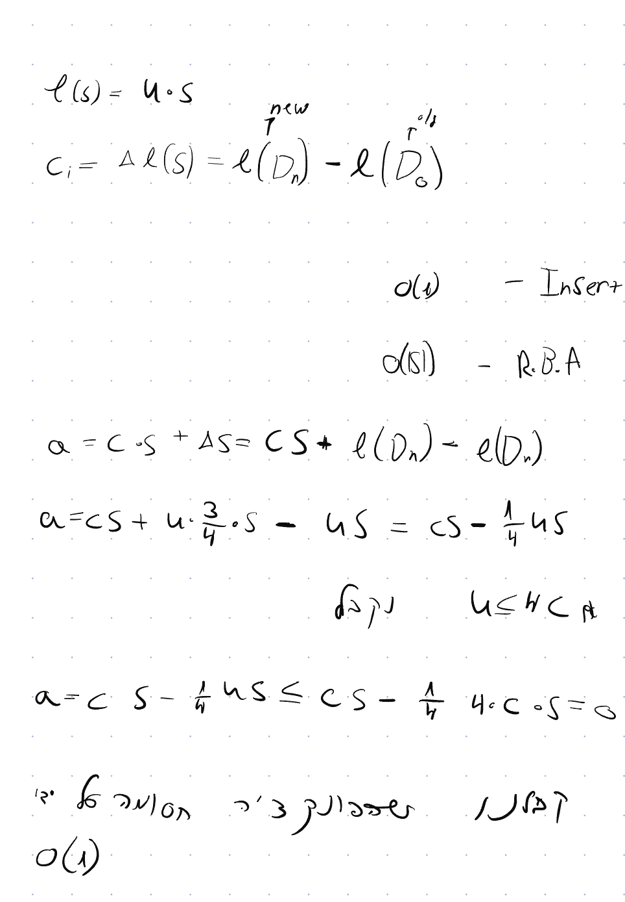

שאלה 3:
כאשר יש לנו עץ 2-3 הגובה יכול לנוע בין
$$\log_{3}{(n)}≤h≤\log_{2}{(n)}$$
ב:
להבנתי מדובר על פעולה של search, אפשר לבצע פעולה זו בצורה יחסית מהירה
$$O\left(\log_{2}\left(n\right)\right)$$
על ידי האלגוריתם הבא
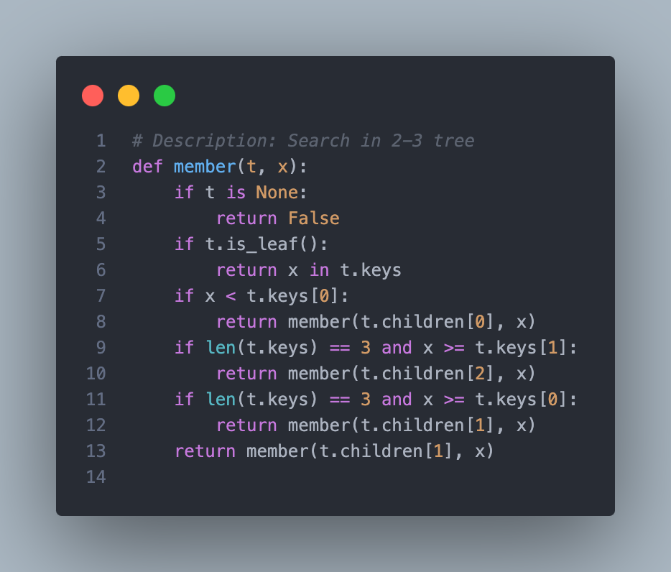

ג:
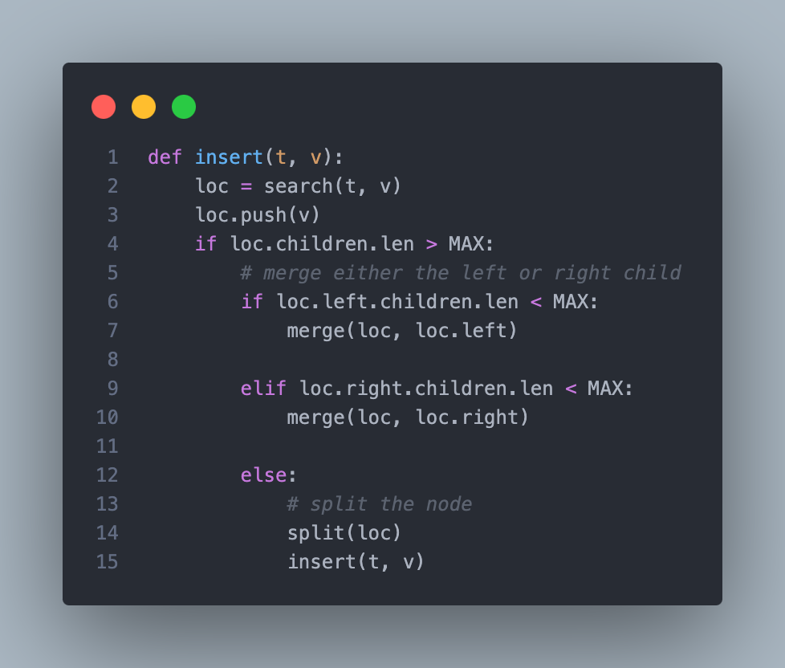

שאלה 4:
We will describe the following algorithm:
First, we will assert W.L.O.G that h1 > h2 and T1 >T2 the algorithm will be very similar for T2<T1.
We will move h2 steps on T1, so we get loc = T1.moveleft(h2) == O(h2)
We will append T2 root to loc == O(1)
If loc.count == 4: O(1)
CreateNewParent(loc) == O(h1)
Else if loc.count == 3: O(1)
FixErrorFrom(loc) == O(h1)
DONE
Function CreateNewParent(loc): O(H)
P = Take the loc[2] and split the items
P.parent.push(P)
If P.silblings.len > MAX:
FixErrorFrom(P)
Return P

Function FixErrorFrom(loc): O(H)
P = Take the middle child and push it to the parent
If P.siblings > MAX:
FixErrorFrom(Loc)

